**Example of Bad Design of Real world:**

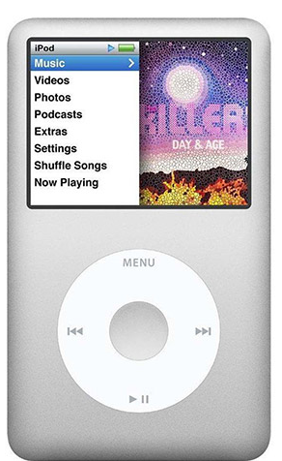

**Visibility:**

Good, but a new person cannot know how to increase or decrease its volume there is no any option for the volume.

**Affordance:**

As it is an i-pod it clearly shows that it is used for listening songs as its design but people may get confused as they may think it as phone because of its size and complexity

**Constraints:**

Restriction is known it is only used for listening songs not for calling anyone as phone. **Consistency:**

Continuous use of ear phone to listen the songs from i-pod may damage our ear.

**Mapping:**

The overall control is done by the menu function and there is left and right direction which indicates to change the song and without ear phone the songs cannot be heard too.

**Feedback:**

Poor does not indicate that videos cannot be played or not and while installing songs it can be installed only by i-tunes.

**Example of Good Design of Real world:**

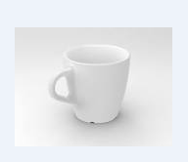

**Visibility:**

Clearly indicates that it is a cup even an illiterate person can know that it is used as cup for drinking water or tea.

**Affordance:**

The design of the cup is so simple that it gives us a clear clue and the handle clearly shows it is used for holding the cup in our hand.

**Constraints:**

It can only be used for drinking tea, coffee, milk and water which proves that it can only be used for drinking liquid purpose.

**Consistency:**

Good it can be used for long time if handle with care it should be prevented from breaking down.

**Mapping:**

The overall control is done by its inner shape to store the liquid and it prevents from passing of heat as it has handle to hold by our finger. Liquids get cooled very fast in comparison to steel glass.

**Feedback:**

Inform us that only fluid can be kept in it not solid things.

**Example of Good Design Website:**

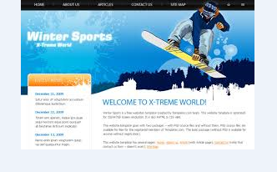

**Visibility:**

Clearly indicates that this webpage gives information about th ice skating with the image and background.

**Affordace:**

As people jump into this web site they will clearly learn this is something related to the winter sport specifically ice skating.

**Constraints:**

The web page clearly indicates it is about ice skating and winter sports , hence the users can get information only about the winter sports.

**Consistency:**

This web page can be used long enough for getting information about the winter sports. And the web page exists until the domain name expires.

**Mapping:**

The web page has clearly mentioned about the five different pages it has in a single task bar (i.e. home, about us, contact us …) at the top of the web page.

**Example of Bad Design of Web site:**

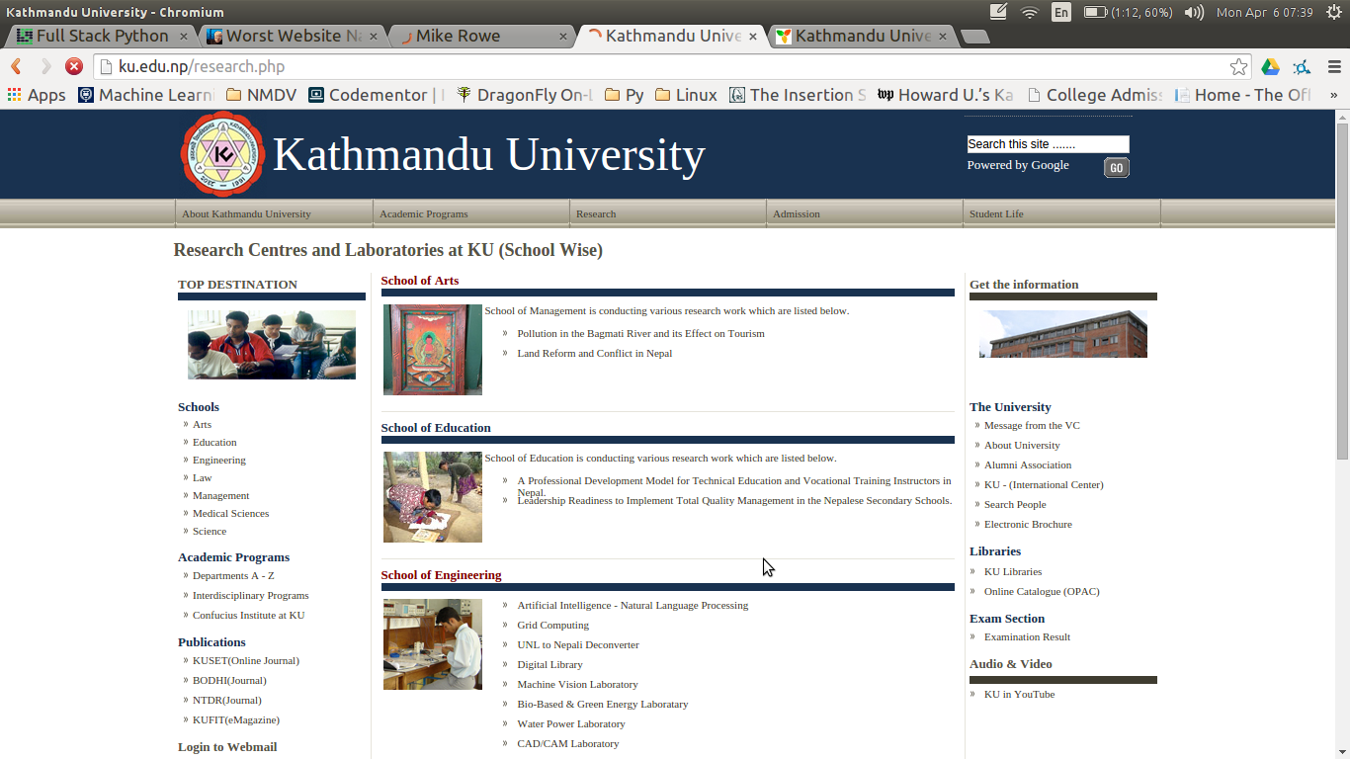

This particularly web page is of the research section of the kathmandu university's official web site. The page looks fine but yet it is a bad design due to following reasons:

**Visibility:**

This web lags in clearly mentioning about the research carried out in the university. Font of KATHMANDU UNIVERSITY is huge that the RESEARCH CENTRE AND LABORATORIES IAT KU. Also the rest of the font should have been little huge in order to catch users' eyes. **So the web page lags Visibility.**

**Affordance:**

As the users jump to this web page they can get all the available information about the research carried in the university. **So the affordance is good**

**Constraints:**

First the web page limits in providing the detail information about the research carried in the university. Only the abstract description are provided and no reference are provided.

**Consistency:**

This web page can be used long enough the university maintains to keep the research program of the university organized.

**Mapping:** Since there are no hyperlinks to the research topics included in the site users cannot get a compete informaiton. So the web page is a bad gesign in case of mapping